**Experiment 8**

**Q1:  
Code:**

**XML Code:**<?xml version="1.0" encoding="utf-8"?>

<LinearLayout xmlns:android="http://schemas.android.com/apk/res/android"

xmlns:app="http://schemas.android.com/apk/res-auto"

xmlns:tools="http://schemas.android.com/tools"

android:layout_width="match_parent"

android:layout_height="match_parent"

tools:context=".MainActivity"

android:orientation="vertical"

>

<TextView

android:layout_width="280dp"

android:layout_height="wrap_content"

android:layout_marginTop="150px"

android:layout_marginLeft="420px"

android:text="Search"

android:textSize="80px"

/>

<AutoCompleteTextView

android:id="@+id/a1"

android:layout_width="280dp"

android:layout_height="wrap_content" android:layout_margin="200px"

/>

</LinearLayout> **MainActivity.java:**

package com.example.exp_8_1;

import androidx.appcompat.app.AppCompatActivity;

import android.os.Bundle;

import android.widget.ArrayAdapter;

import android.widget.AutoCompleteTextView;

public class MainActivity extends AppCompatActivity {

AutoCompleteTextView a1;

String[] str = {"Cars", "Cats", "Cat", "Car", "Google", "Yahoo", "Youtube", "Resident Evil"};

@Override

protected void onCreate(Bundle savedInstanceState) {

super.onCreate(savedInstanceState);

setContentView(R.layout.activity_main);

ArrayAdapter <String> adapter = new ArrayAdapter<String>(this, android.R.layout.select_dialog_item,str);

a1 = (AutoCompleteTextView)findViewById(R.id.a1);

a1.setThreshold(1);

a1.setAdapter(adapter);

}

}

**Output:**

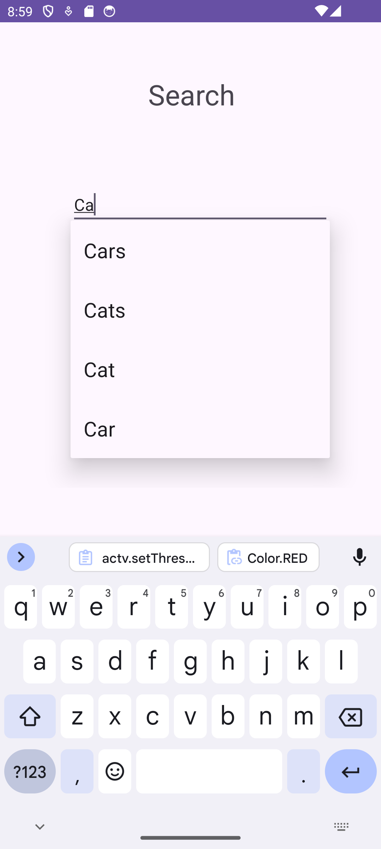

**Q2:**

**Code:  
XML Code:**

<?xml version="1.0" encoding="utf-8"?>

<LinearLayout xmlns:android="http://schemas.android.com/apk/res/android"

xmlns:app="http://schemas.android.com/apk/res-auto"

xmlns:tools="http://schemas.android.com/tools"

android:layout_width="match_parent"

android:layout_height="match_parent"

tools:context=".MainActivity"

android:orientation="vertical"

>

<TextView

android:layout_width="280dp"

android:layout_height="wrap_content"

android:layout_marginTop="150px"

android:layout_marginLeft="250px"

android:text="Search Subjects"

android:textSize="80px"

/>

<AutoCompleteTextView

android:id="@+id/a1"

android:layout_width="280dp"

android:layout_height="wrap_content"

android:layout_margin="200px"

/>

</LinearLayout> **MainActivity.java:**

package com.example.experiment_8_2;

import androidx.appcompat.app.AppCompatActivity;

import android.os.Bundle;

import android.widget.ArrayAdapter;

import android.widget.AutoCompleteTextView;

public class MainActivity extends AppCompatActivity {

AutoCompleteTextView a1;

String[] subs = {"MAD", "ETI", "WBP", "CPE", "MGT", "WMN"};

@Override

protected void onCreate(Bundle savedInstanceState) {

super.onCreate(savedInstanceState);

setContentView(R.layout.activity_main);

ArrayAdapter <String> adapter = new ArrayAdapter<String>(this, android.R.layout.select_dialog_item,subs);

a1 = (AutoCompleteTextView)findViewById(R.id.a1);

a1.setThreshold(1);

a1.setAdapter(adapter);

}}

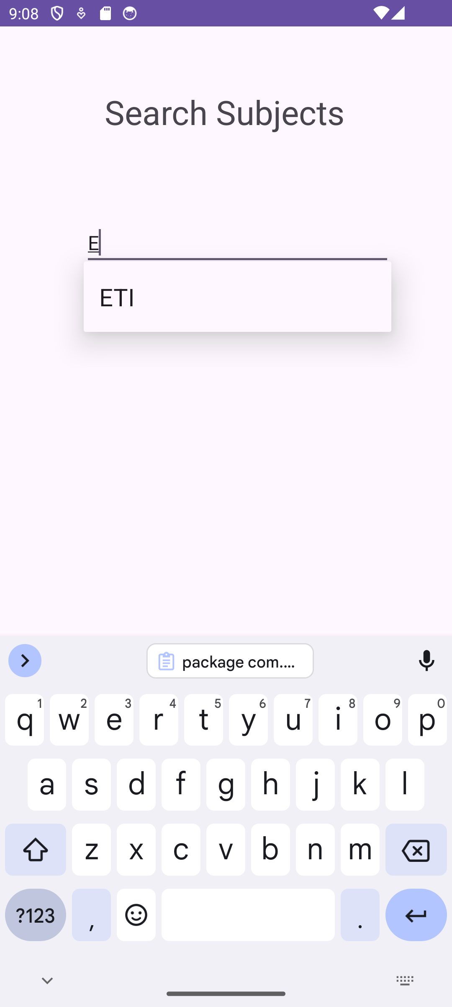**Output:**